**Monitoring:**

Creating New instance for monitoring Setup

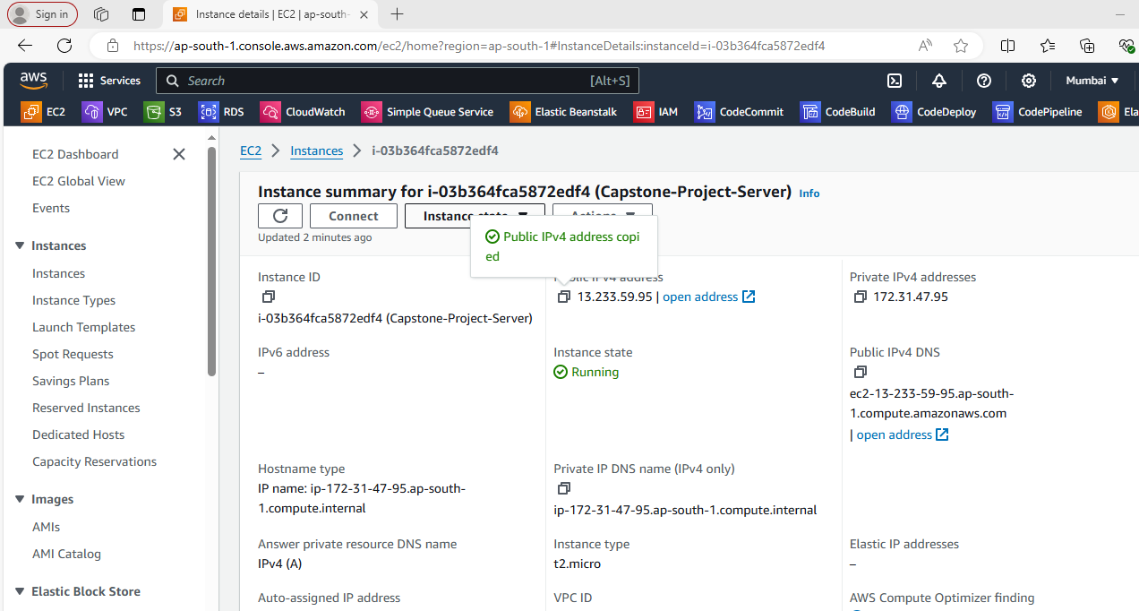

Connecting to server via Mobaxsterm application

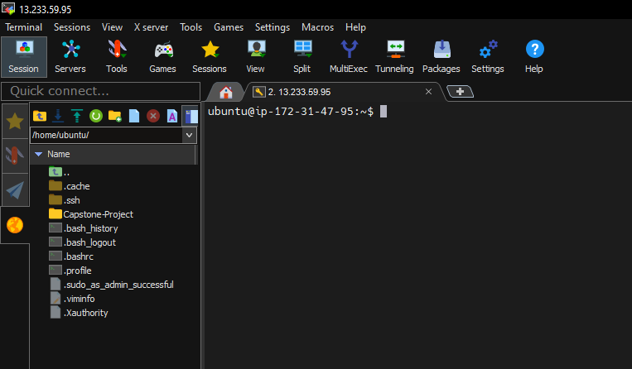

Cloned capstone project already pushed to github repository

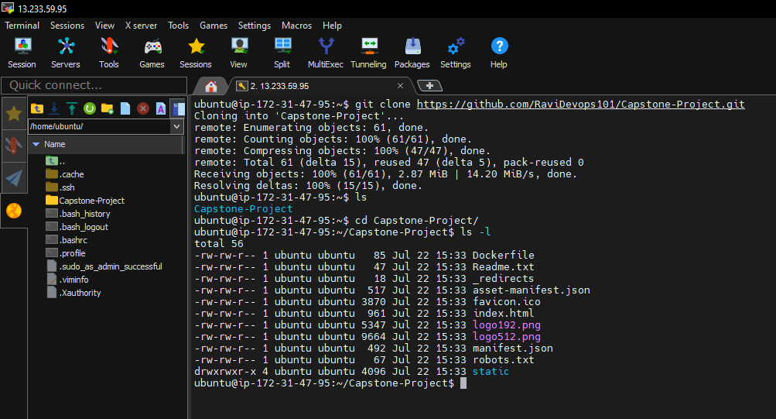

Created a nginx config file to build and run the docker image with nginx exporter

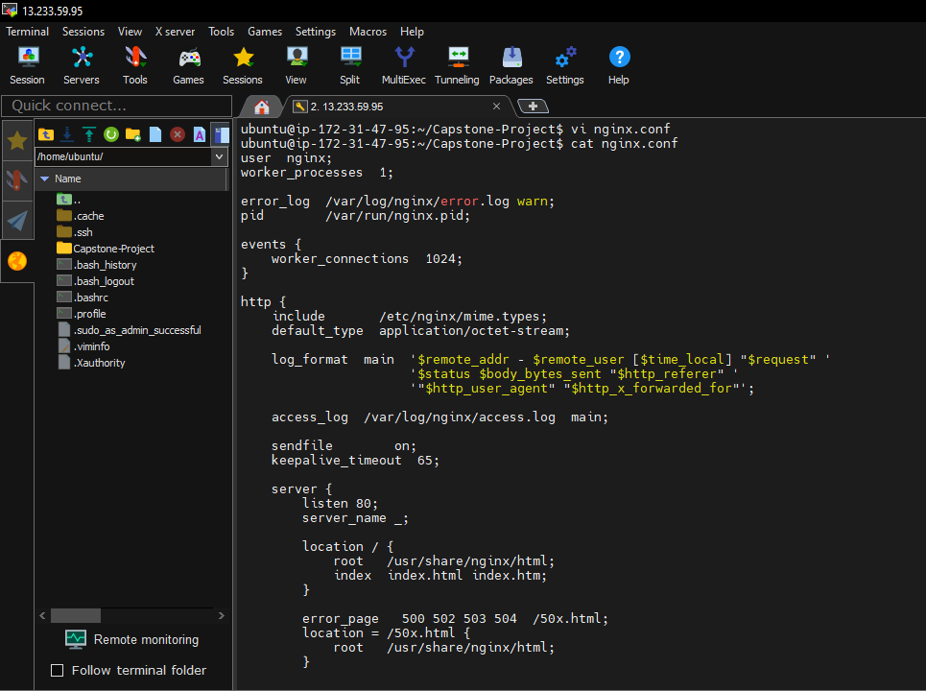

Build the docker image

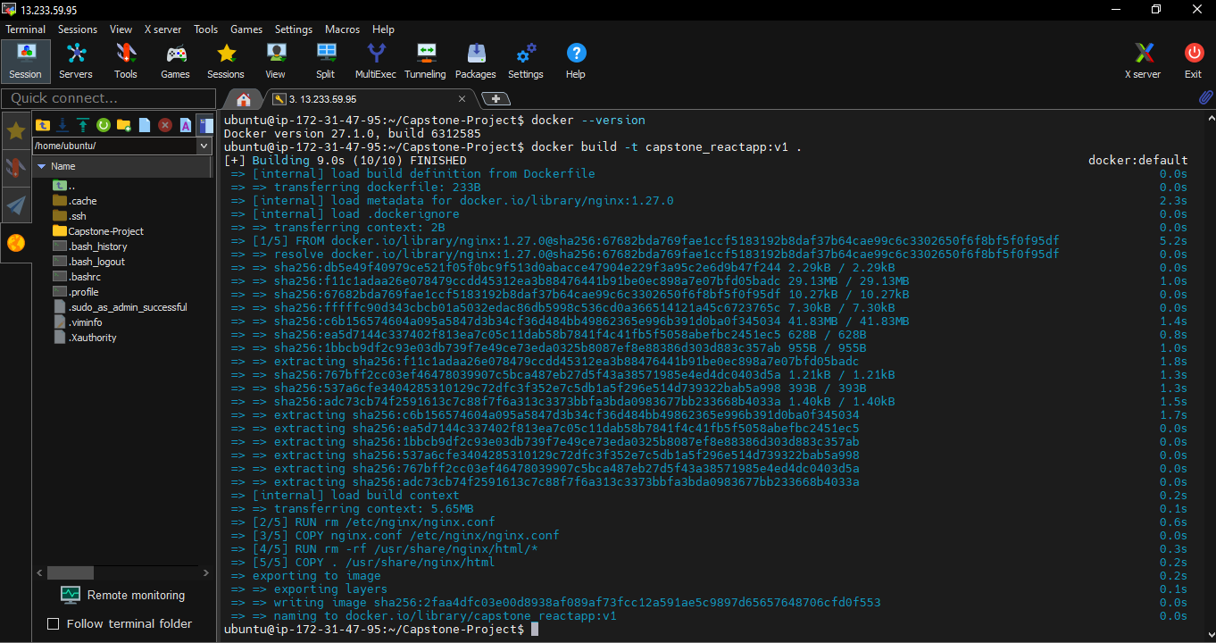

Docker container started

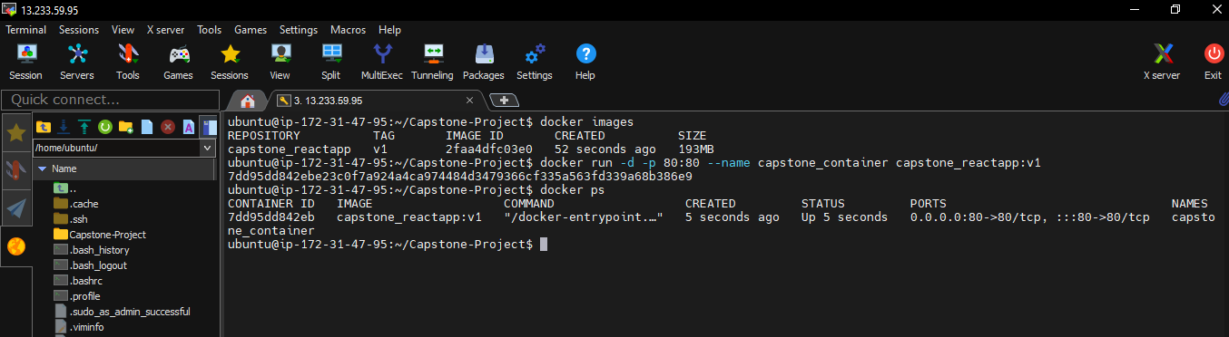

Output URL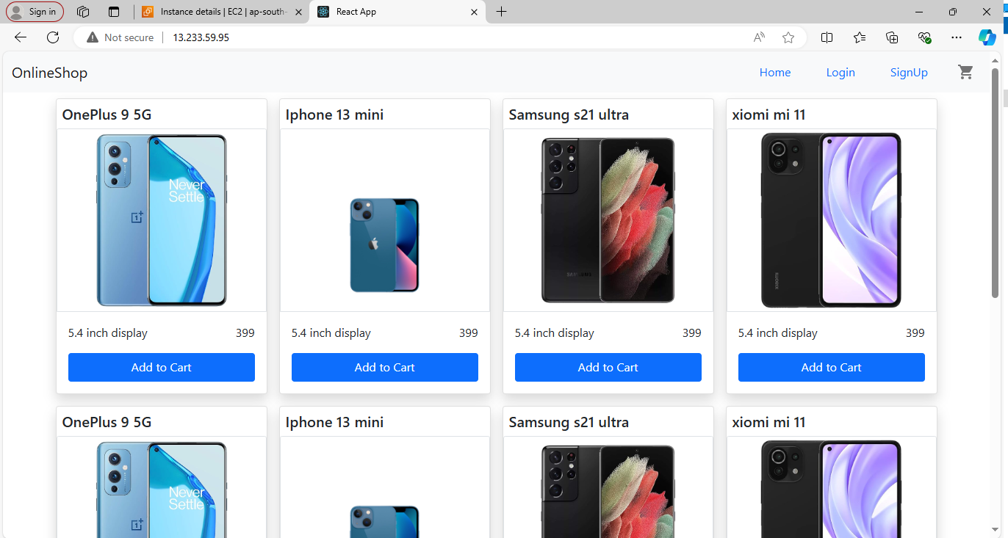

Downloaded Prometheus using wget command

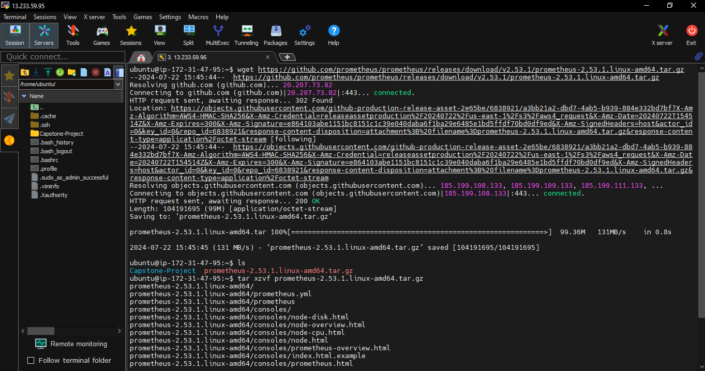

Installed Prometheus success

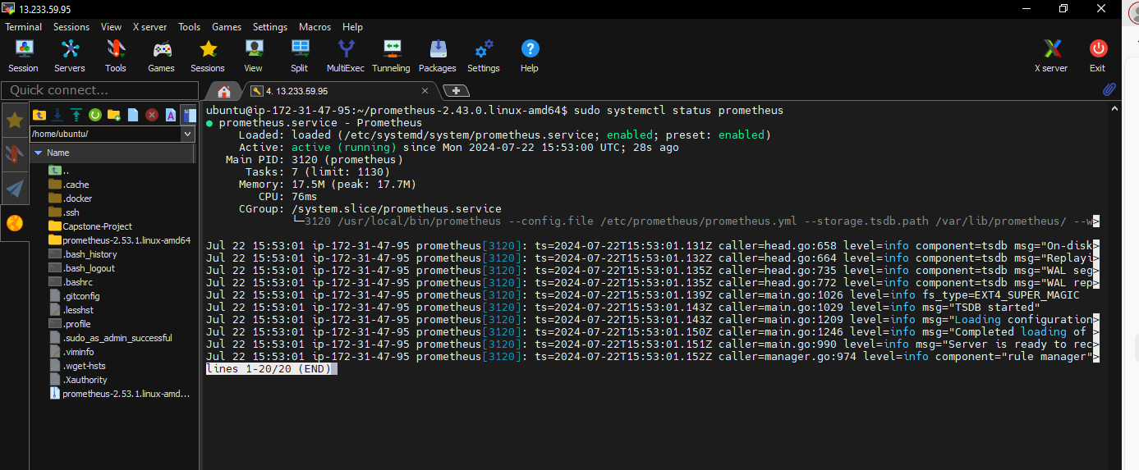

Prometheus URL

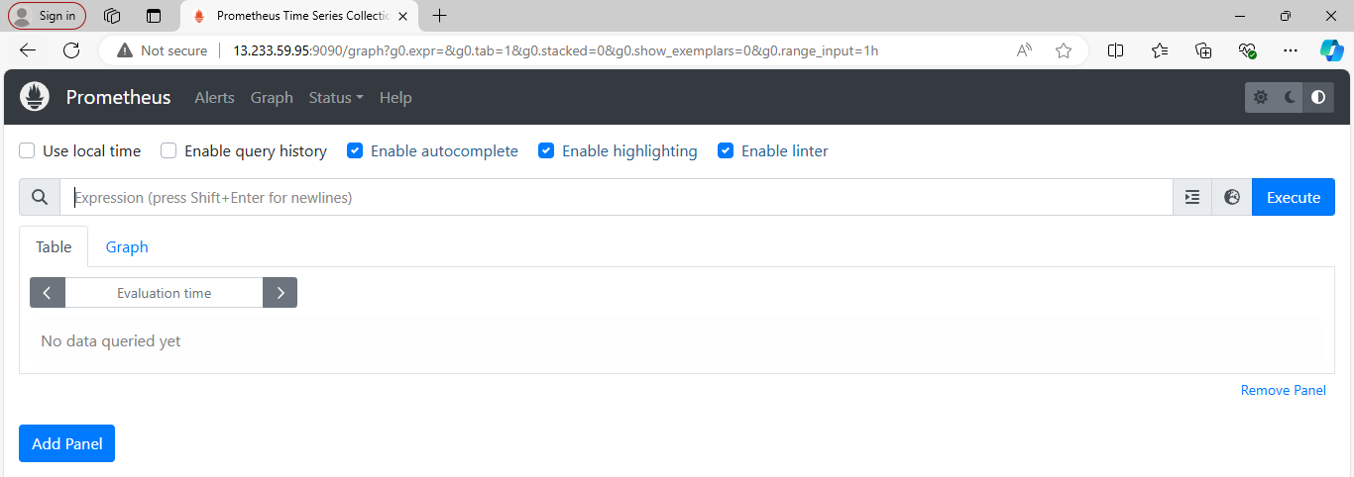

Installing alert manager

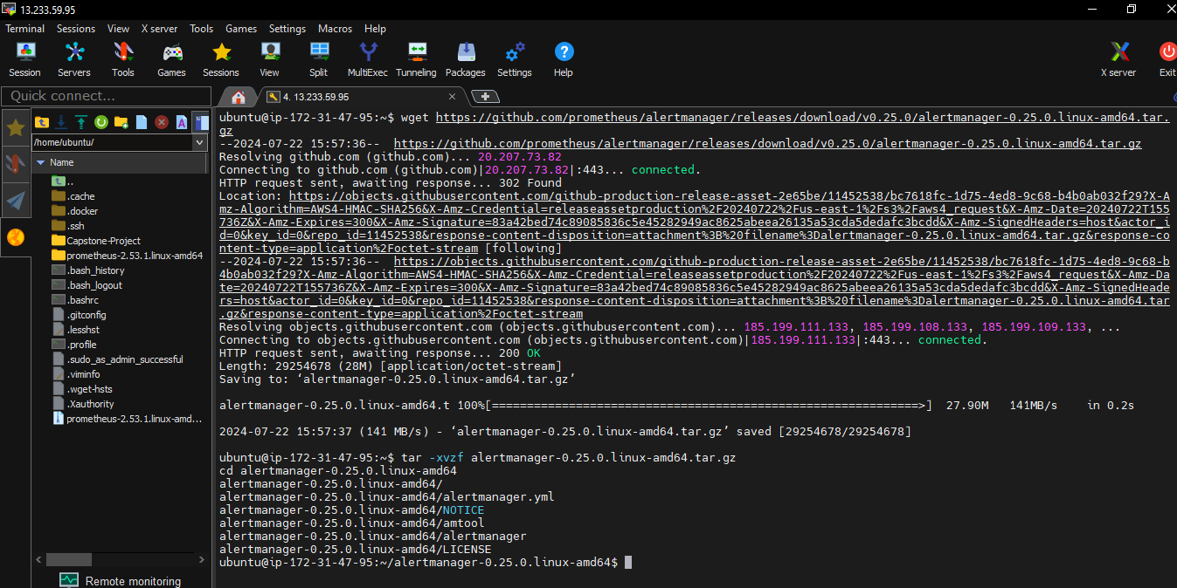

Alermanager install success

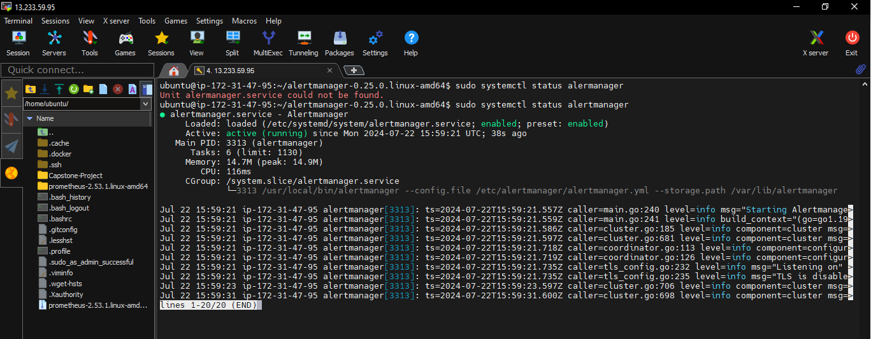

Alertmanager URL

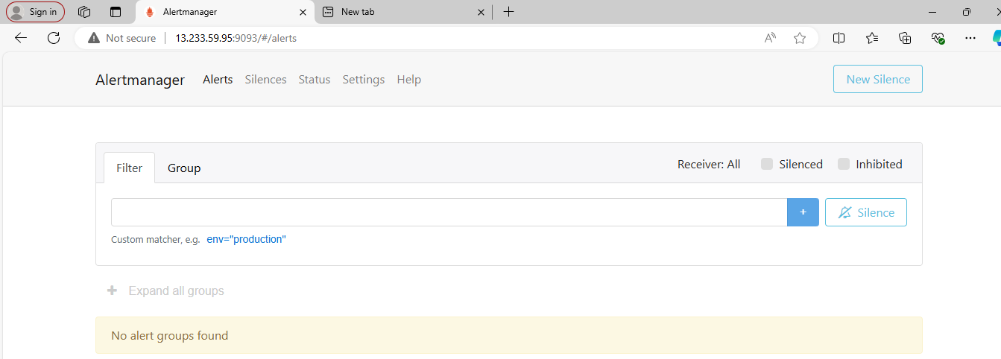

Configured email settings in alertmanager.yml

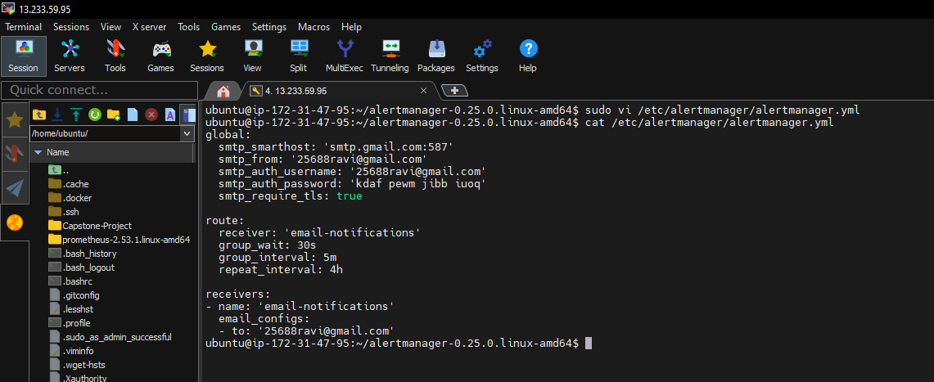

Configuration of Prometheus.yml file

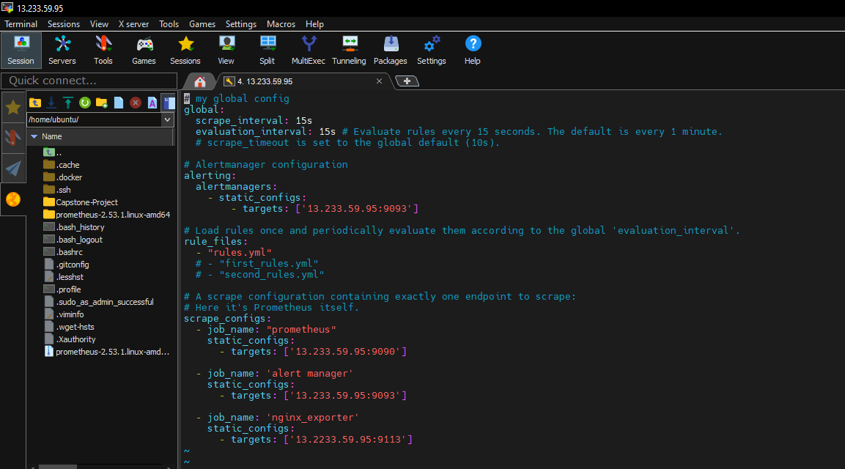

Created rules.yml file and configured

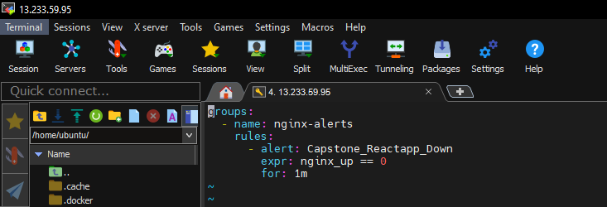

Installed nginx exporter for Prometheus metrix for docker container

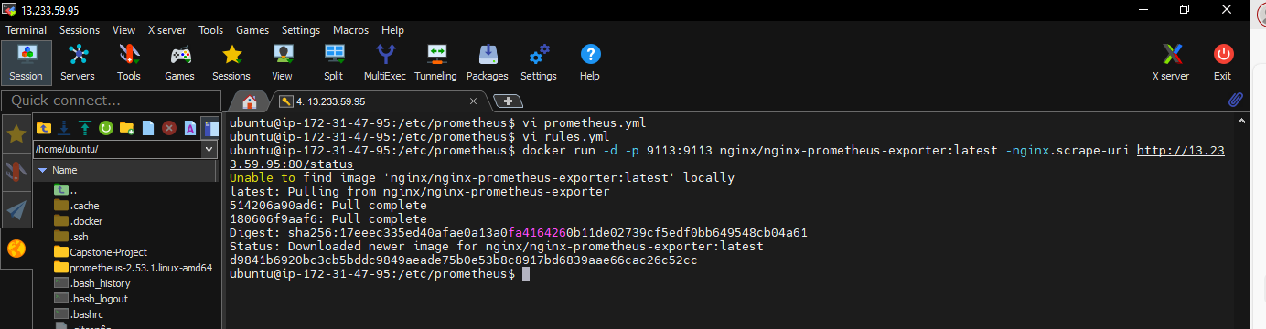

Checked promethuus.yml file with promtool check config

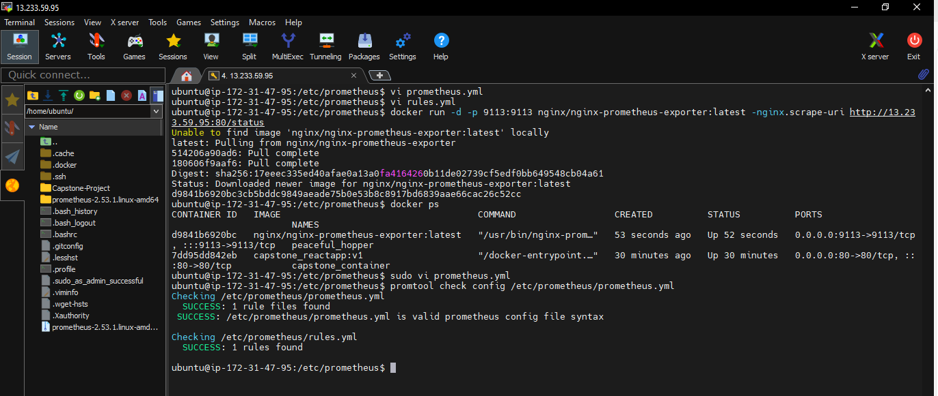

Targets page in promtheus URL

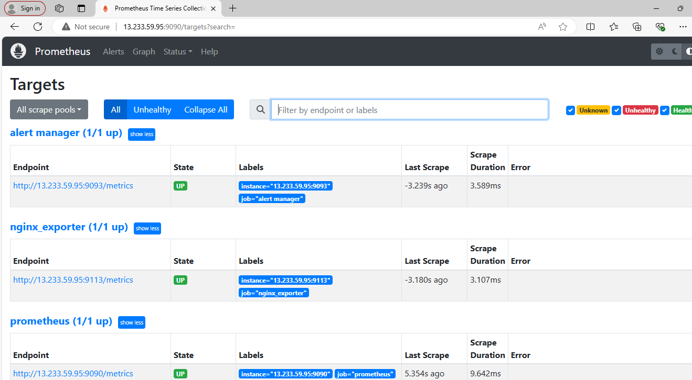

Now the application is running fine

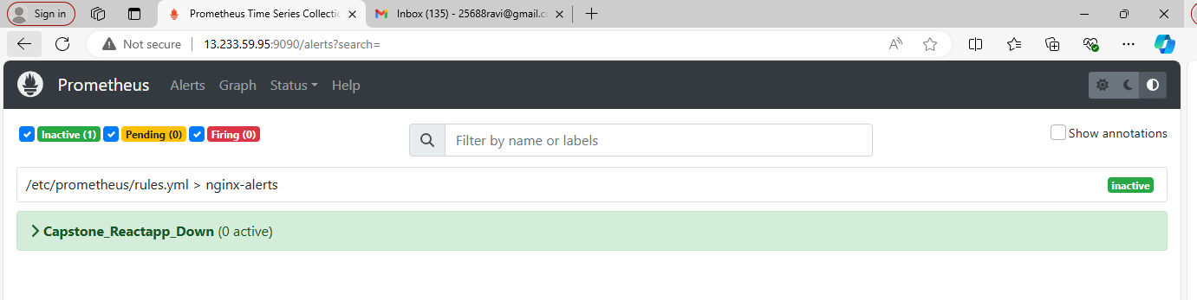

Now stopped the capstone coantainer

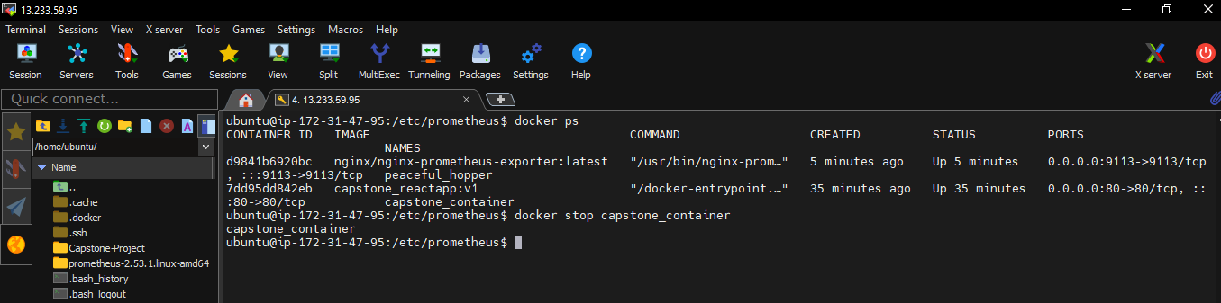

Now the alert page has changed to pending stage after a minute

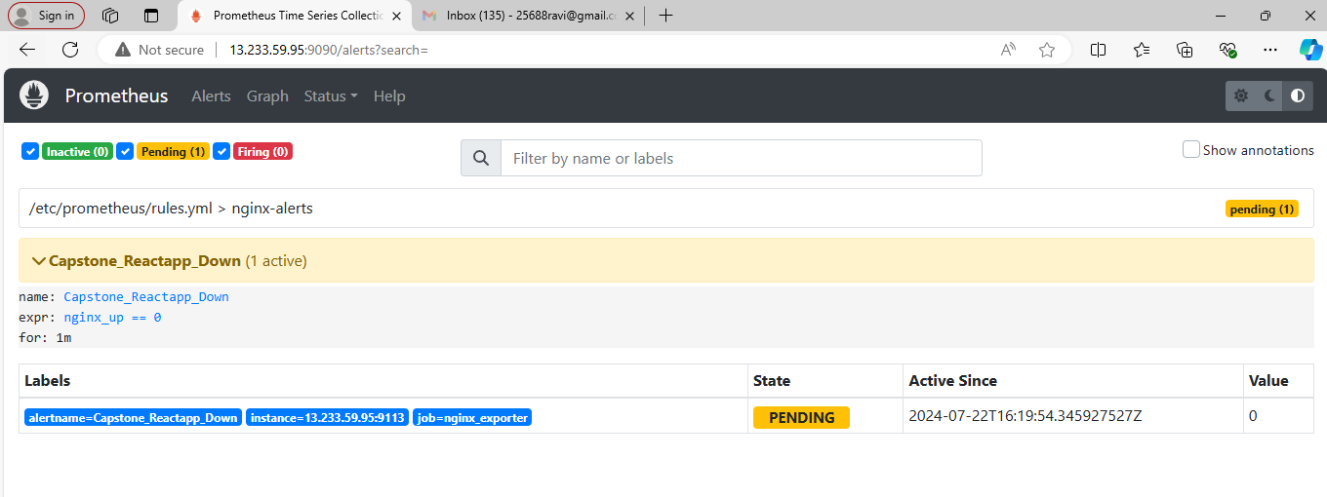

Now in firing stage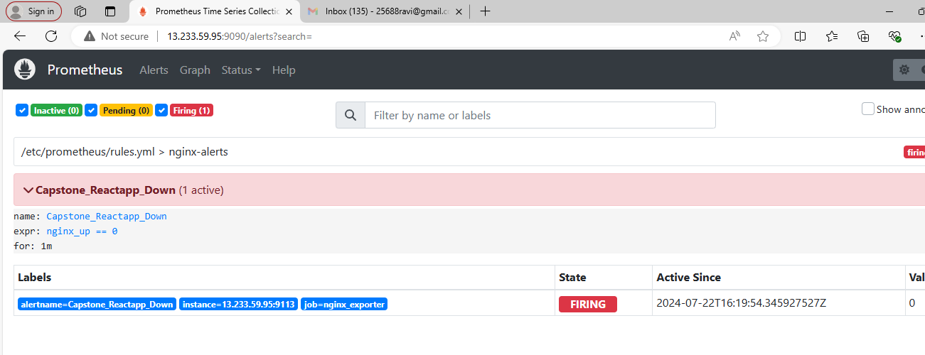

In alertmanager URL page has been created

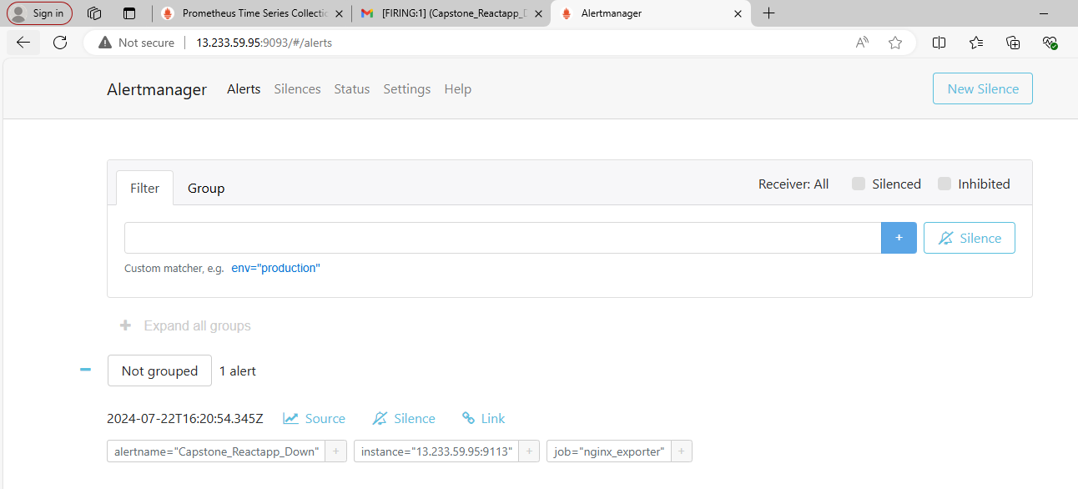

Finally alert e mail has been received

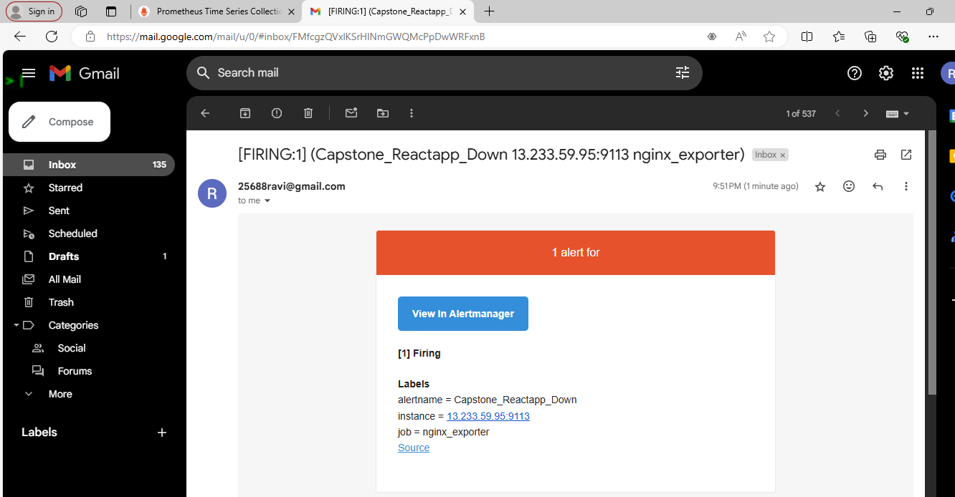

Docker container startd again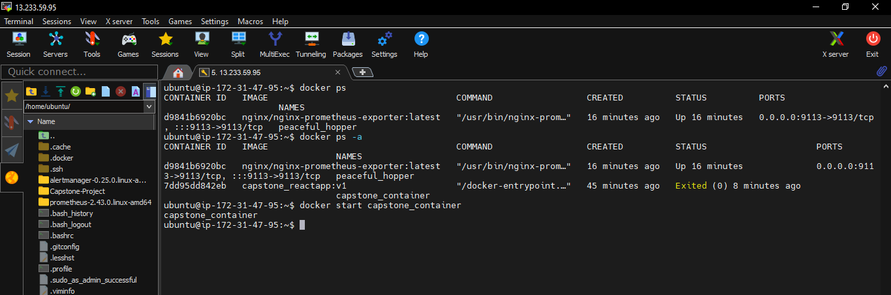

Alert goes up

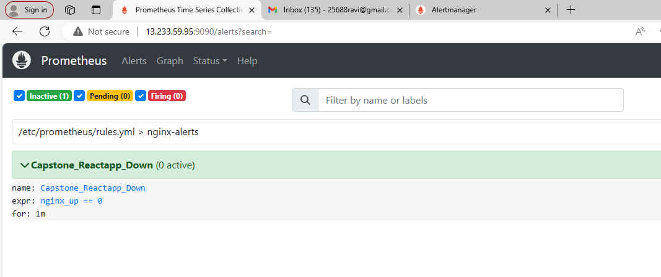

Grafana Setup

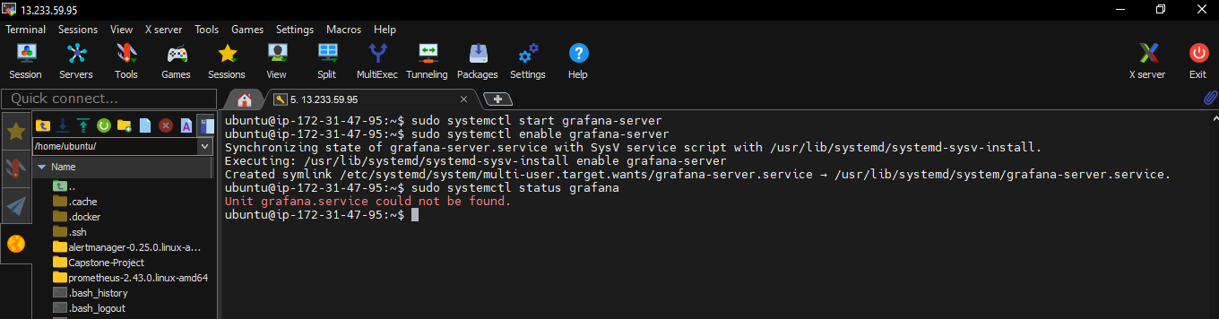

Grafana URL – grafana hom page

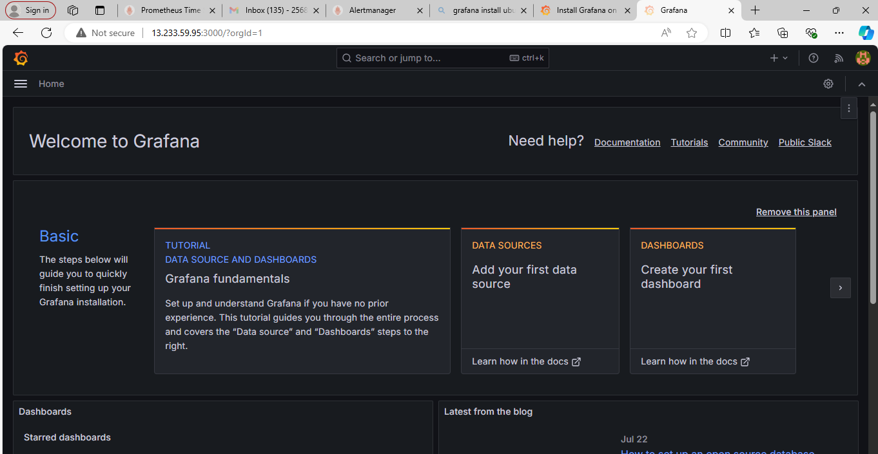

Added Data source as Prometheus

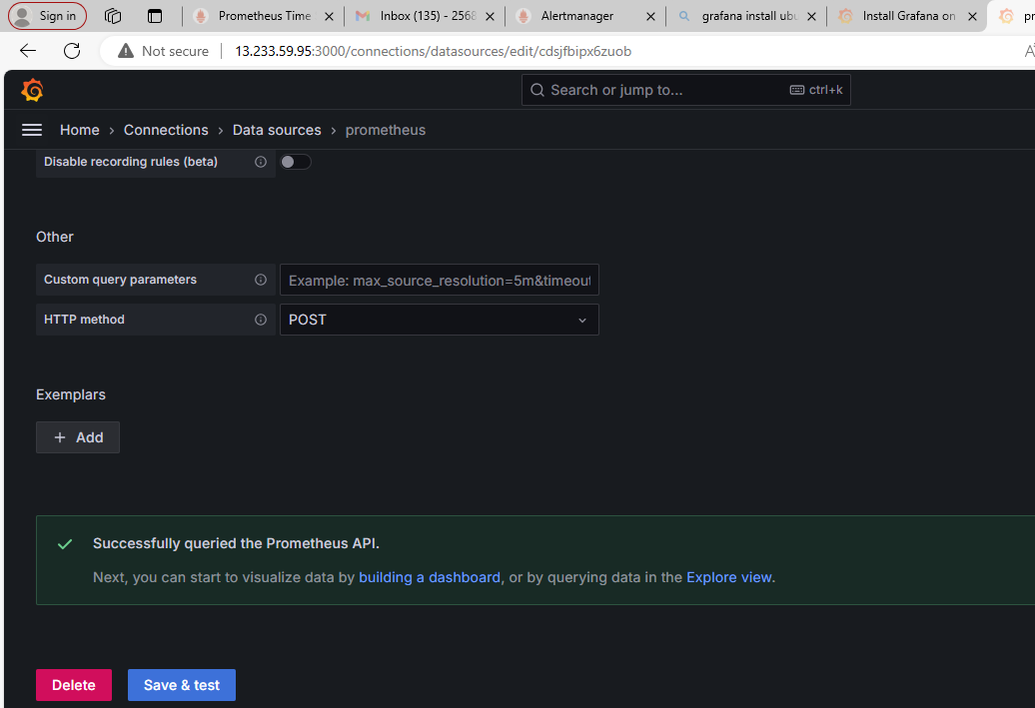

Data source added as Prometheus

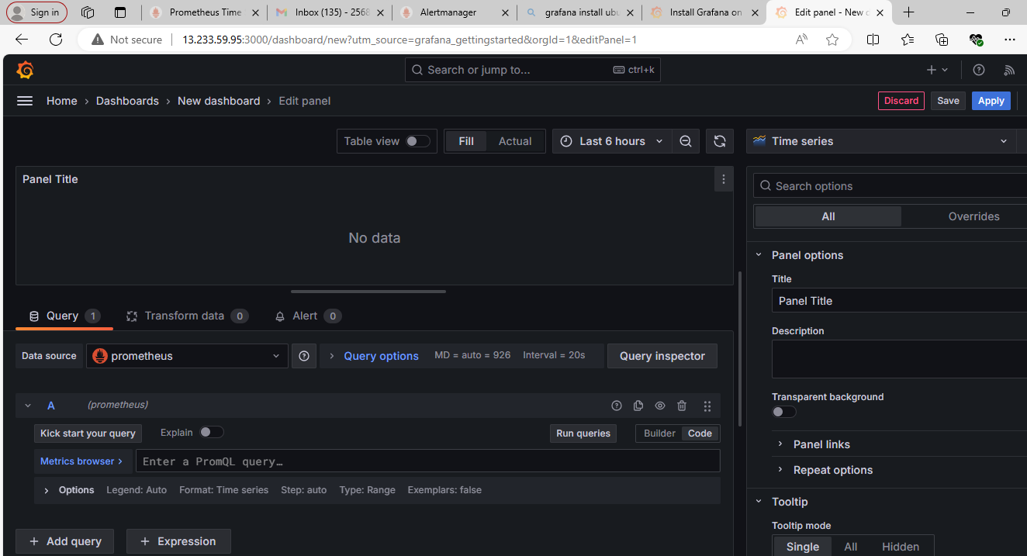

Stopped application to check grafana graph

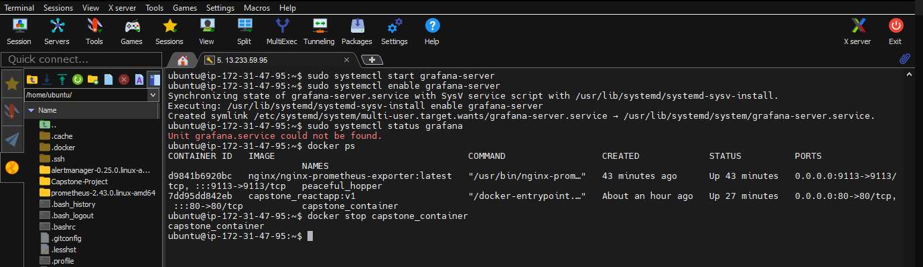

Grafana page after stopping application

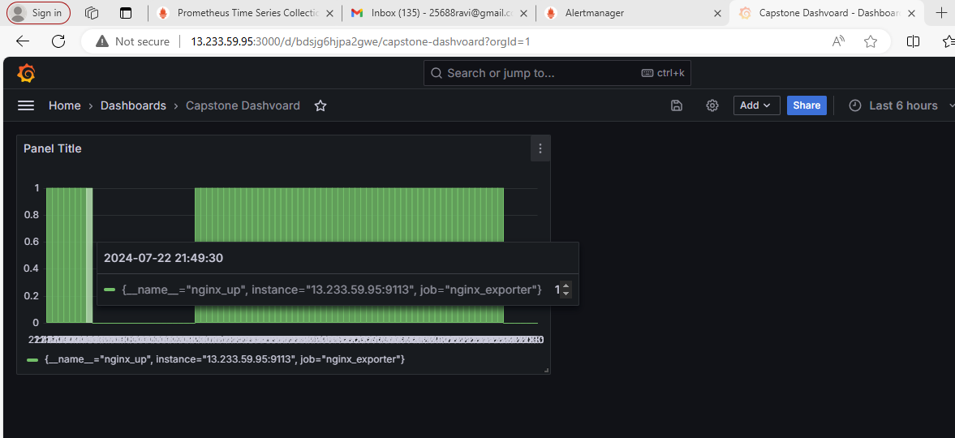

Final step

Application started again

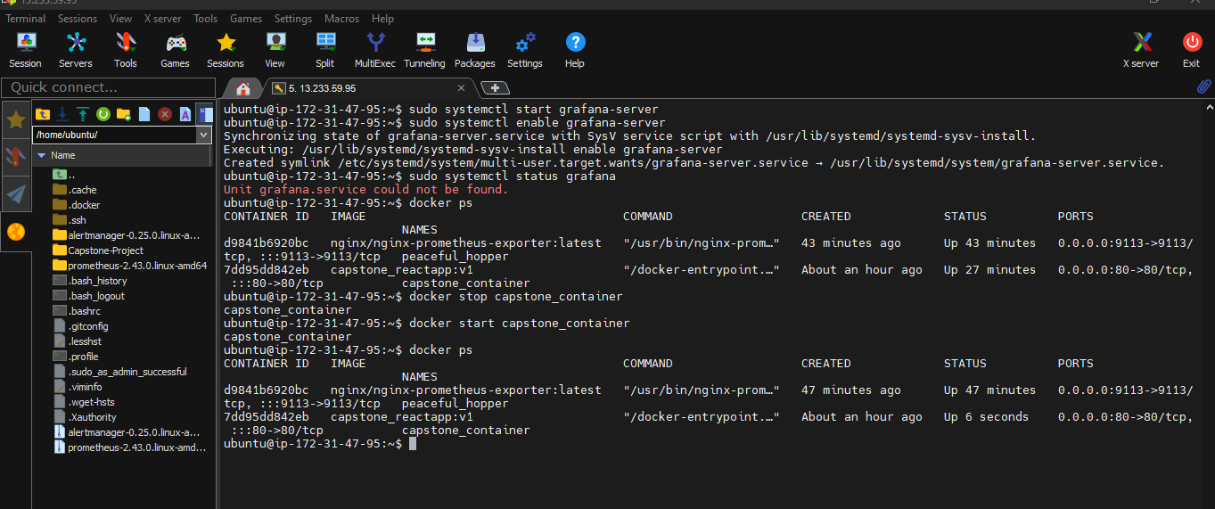

Grafana page after starting application

